OSC Bulletin – Remove First Name from Registration Wizard

The purpose of this bulletin is to inform you of planned changes to the Registration Wizard in MyEducation BC. The proposed change has been developed by the Operation and Standards Committee and the Service Management Council’s Priorities Task.

Please direct your questions or concerns about the planned change to Ian Larsson (Ian.Larsson@gov.bc.ca) or Judy Smith (Judy.L.Smith@gov.bc.ca).

Business process issue is associated with
Schools use the registration wizard to enrol students continuously throughout the year.

Detailed description of issue and recommended approach for resolution
Issue
There have been an unprecedented number of duplicate students created in MyEducation BC for a number of reasons. One reason is that the registration wizard allows users to enter a first name search parameter. The search results often do not return a matching student because the user has entered the first name incorrectly, or has entered the first name in the last name field.

Proposed Solution
The Province requested a change to the registration wizard to ensure that the first name field cannot be populated from the Registration Wizard > Student Registration: Select Student template.

Fujitsu will remove the first name field from the wizard. Implementation is targeted for June 15, 2016.

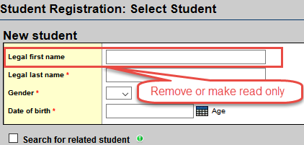

Impacts
Fujitsu will remove the “Legal first name” field from the Registration Wizard > Student Registration: Select Student template as illustrated above.

Benefit of implementing the change
The change is expected to reduce the number of duplicate records created.

About the Operation and Standards Committee

The Operations and Standards Committee is a standing advisory committee of the Service Management Council that provides recommendations to the SMC Executive Committee and advice to the MyEducation BC Team regarding the standardization of business practices, common operational procedures, schedules, security and privacy procedures, software configuration, and coding within MyEducation BC.

