Operations and Standards Committee Bulletin March 2016 #3
The purpose of this series of bulletins is to provide information to L1 support personnel about current MyEducation BC business process items of interest and note. Please review the information and share with users in your district. Contact Judy Smith (Judy.L.Smith@gov.bc.ca) or Ian Larsson (ian.larsson@gov.bc.ca) if you have any comments or find missing requirements.

Pre Registered Students
Because Pre Registered students are not active in their new school until next year, it is possible for a school to query and register a student who has already Pre Registered. When this happens, the student disappears from the Pre Registration list at the first school and is registered at the new school - and two ENTRY records exist on the student membership record with no withdraw record. This is an issue when parents try to register at multiple schools because they are undecided.

The standard practice for all schools is that no one should register a student with the status of PREREG without having a conversation with the other school. If it is decided that the student is actually going to attend the other school, the first school needs to withdraw the student with the code “No Show” in order for the membership record and PSR to be correct. A phone call goes a long way to sorting out where a student should be registered.

Next School Value
Schools should NOT use OOP or OOC as the next school for Pre Transition as you will not be able to access the student record after EOYR. Instead, leave next school BLANK and check WITHDRAW AT EOY for students who are leaving the BC school system.

Cross Enrollment
Never end a cross-enrollment at another school. That part of the student record belongs to the secondary school. The primary school should notify the secondary school(s) when the student withdraws from the primary school. When the primary school withdraws the student, the student becomes Active No Primary and the secondary school association stays intact. If the secondary school is the new School of Record, it registers the student and becomes primary.

Active No Primary Students
When a student withdraws from their primary school and they have an active secondary school association, their status becomes Active No Primary and their membership record indicates W and Active No Primary.
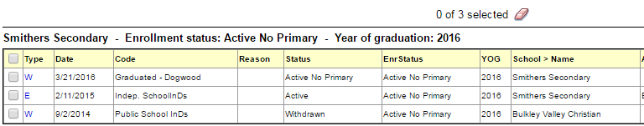
When the student is finished at the secondary school, the secondary school WITHDRAWS the student. This completes the withdrawal cycle and creates an accurate membership record.
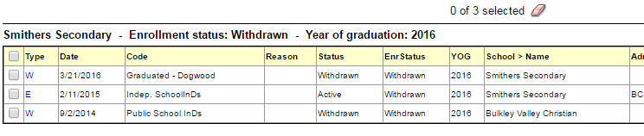Naming IDS Courses
The Handbook of Procedures for the Graduation Program gives guidelines for naming IDS courses. Some examples that follow their guidelines are:
IDS Art Foundations 11A
IDS Fitness and Weight Training 12B
We encourage districts to follow this guideline to provide consistency for students who study in several schools and districts.

Empty Fields in the IEP
Schools have asked if fields with no data on the IEP can be masked on printing – ie. not print. The Student Services Resource Group has investigated this and it is not possible. In their review they recommend that all fields be completed. The one exception is the ADJUDICATION field that only applies to provincial exam adjudications. If a student is not writing provincial exams, their IEP should say “Not Applicable” in that field. Case Managers should ensure all other fields contain relevant information about the student.

Summer School – what we know
Work has been started on the Summer School process for this school year. A Learning Event on Summer School Set Up and Management is scheduled on April 12 at 1pm and we encourage all districts that host a summer school to attend.

About the Operation and Standards Committee
The Operations and Standards Committee is a standing advisory committee of the Service Management Council that provides recommendations to the SMC Executive Committee and advice to the MyEducationBC Team regarding the standardization of business practices, common operational procedures, schedules, security and privacy procedures, software configuration, and coding within MyEducationBC.

