Operations and Standards Committee Bulletin March 2016

Names, Gender and Preferred Gender
Some students have a different usual name than their legal name. This is the name the student prefers to be called by and, in some identity protection cases, it is the name that MUST be used. Currently there are some field sets in STAFF VIEW that you can’t modify in MyEducation BC: Class Input & Class Seating Chart.
It is recommended that you print a paper attendance list for TTOC’s when you have sensitive name issues at your school. The Attendance TT – Class Office ST – Reports – BC Class Student List report uses Usual Names for class lists. The Attendance TT – Daily Office ST – BC Homeroom Student List report uses usual names for homeroom lists.
There is also a PREFERRED GENDER field in MyEducation BC. Schools and Districts can add to this reference table based on your District policy. The preferred gender field can be added to your School or District field sets. If you do use this field remember it needs to be populated for all students for it to show up on quick reports and field sets properly. Use Mass Update, Modify List or the Student Demographic tab as needed to populate this field.
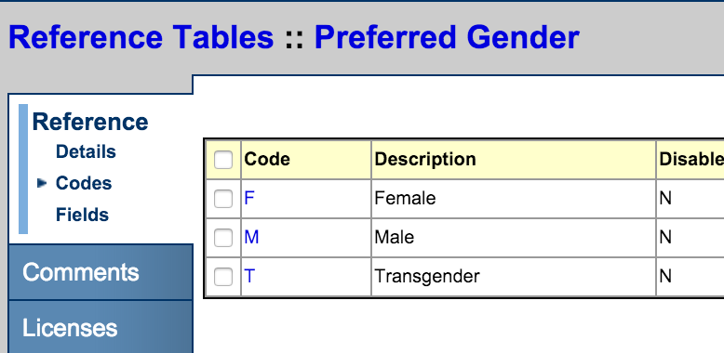
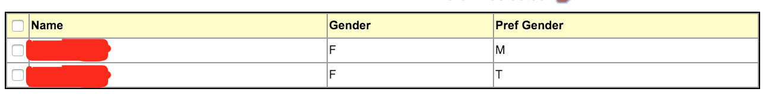

Programs

Students are assigned programs in MyEducation BC for 1701 data collection and tracking participation in local programs. 1701 programs include programs like Core French, Aboriginal Support, Career Programs and others. Local programs may be academy programs or specialty programs within a single district or school.
Schools should only add programs for their own school. When a student withdraws, only end programs from your own district. Secondary schools will end their own programs.

If a student arrives at your school with no secondary or former school associations you can end date programs for other schools. If you are unsure if the program has ended, contact the other school.

Assigning a Graduation Program (Program of Study)
When a student enters the graduation program (grade 10) a Program of Study must be assigned to them. For most students, this will be the 2004 - Graduation Program.
Graduated adults (those who have graduated either in BC or another jurisdiction) are assigned the graduation program that they graduated on previously. If that is not known, use the most recent graduation program (currently 2004 - Graduation Program). The Ministry transcript for these students will be updated with the results in new courses taken upon TRAX upload. Graduated adults should not be assigned the Adult Graduation program unless that is the program they previously graduated on.
To assign a Program of Study use the Program of Study Creator-Primary to create a primary program of study for your students. This will mass assign the selected Program of Study to all students by selected grade. Usually this will be a once a year job for your new students coming in. e.g. Grade 8’s if you are an 8 to 12 school.
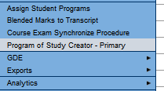
You will then need to update the Program of Study for those students not on the 2004 Graduation Program. This can be done from the Global TT – Favorites –Graduation Student Program table Options – Modify List
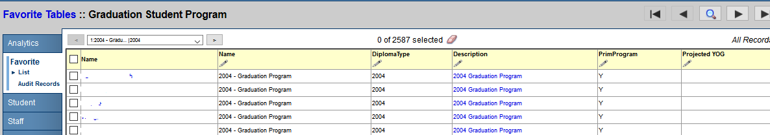

Diploma Granted Date
Districts should have a clear policy about entering the Diploma Granted Date for graduating students. Regardless of when a district chooses to enter the date, records must be updated when final exam results are uploaded and graduation is either confirmed or not achieved. If a non-graduating student is no longer available to your school after EOYR, it is important to contact the new school so they can update the record. Note that filling in this date does not prompt graduation and that this date may not match the official ministry transcript. This field can be updated for the Student TT. Select the Diploma Granted Date field set, Query for your graduated students and Mass Update or Modify list as appropriate.

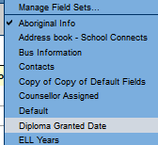

Deceased Student
If a student dies, they are withdrawn; the withdrawal code is Death. This code is not to be used for any other reason. The major issue with a deceased student is that if the deceased student was a sibling they would show up on the student verification form. Withdrawn students no longer show up on the student verification form. It is still good practice to remove the sibling connections to ensure that the deceased student does not accidently show up on any reports.

Deceased Parent/Contact
Remove the deceased parent/contact from the contact list, add a family alert and a memo if needed. If a district wants to record deceased dates, add these to memo field. Father Deceased Date, Mother Deceased Date fields are not needed and should not be used, these field will be reused for other purposes. (Notification to teachers and counsellors is assumed to occur through a more personal form of contact).

About the Operation and Standards Committee
The Operations and Standards Committee is a standing advisory committee of the Service Management Council that provides recommendations to the SMC Executive Committee and advice to the MyEducationBC Team regarding the standardization of business practices, common operational procedures, schedules, security and privacy procedures, software configuration, and coding within MyEducationBC.

