Operations and Standards Committee Bulletin February 2016

Important: Course Changes and Final Marks
AKA: avoiding orphaned (zombie) records

MyEducation BC keeps a student attached to a course after they have withdrawn. These students can be seen on the grade input screen by choosing the WITHDRAWN button.

When a student is withdrawn, a final mark MUST be entered for the student in the grade input screen rather than the transcript record – likely W for Withdrawn. If you don’t enter a final mark, when grades are posted, the empty final mark field will overwrite any entries you have made in the transcript record – thus creating an orphaned or zombie record.

Note: there are some course records you will want to delete. This is a complex process outlined in a document posted on the Yammer site.

We will be developing a process that is more automated in the future. This is the current process.

Pre Registration Process
Instructions for registering new students can be found on the MyEducationBC.info website under Resources > School User Resources

Registration:
Enrolment Management v1.7 (will need updating soon so page numbers may change slightly)
Admitting new students section 2.1 pages 6-11
Pre-registration is in part (d.) of section 2.1 currently on page 8

Next School:
End of Year Roll Over v3.0 (was just updated, page numbers should stay the same for a while)
Next School instructions section 2.3 page 6

Reminder to NOT HOLD Withdrawals
If a student is leaving your school for another school, it is important to withdraw the student immediately so the next school can begin taking attendance and such. When you withdraw, create a Former School Association. That will allow you to update any records for the student that you have created. Do each other a favour and release students the day they leave.

New Course Codes Not Available
The new K-9 curriculum will have some new course codes. At this time, we don’t know what they will be or when they will be available to us. For the time being, schedule your school using existing course codes. When the new course codes are available we’ll give further instruction. This may be as late as August.

Syrian Refugees and February 1701
New refugees from Syria are arriving as Permanent Residents but must be reported in the February 1701 as Newcomer Refugees. In the registration wizard, be sure to use the Entry Code “Refugee”. In the citizenship sub top tabs, you have two options:

1. Enter their citizenship as Permanent Resident and update your 1701 webform to indicate 16 Newcomer Refugee in the School Funding Code field before you submit it.

2. Enter your Citizenship Code as Refugee then update your MyEducation BC records after your 1701 submission. Be sure to double check your webform to ensure the “16” populates.
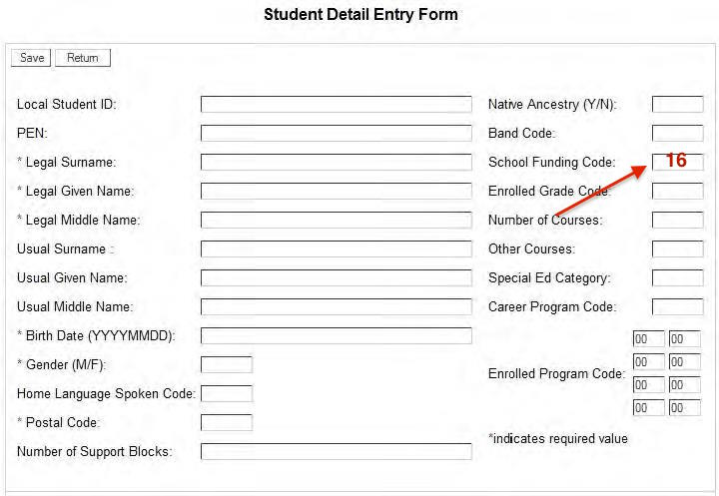

Schools/districts can verify that the students have been indicated as a newcomer refugee in their 1701 echo reports. This can be verified by viewing district echo report 8095 or looking for funding code “16” on school echo report 9100. Funding code 16 may need to be entered manually in the 1701 web application.

Questions regarding the web submission for these students can be directed to Mike.Joa@gov.bc.ca

Confidential Students
A confidential student flag can be enabled for students by entering a date in the Confidential Student Date field. Once the flag is enabled, students cannot be queried in the Register Student screen or the Student Siblings screen except by their primary school. The purpose of this flag is to ensure that student information is available to only the primary school in cases where the student’s privacy or safety is threatened. Examples of this include:
- Students in custody.
- Students in a transition house.
- Students who are under legal protection (Peace Bond or Restraining Order protecting them from someone).
- Students identified by administration as needing their privacy protected.
Districts should have guidelines around the use of this flag and use it only as needed in order to prevent inadvertent creation of duplicates. For example:
- Which students will be deemed confidential?
- Will these guidelines be documented and by whom?
- Who will have the security role assigned to check the flag and take it off?
- How will movement of the confidential student be communicated to the person responsible for the confidential flag security role?

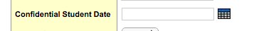

School staff with this access must understand the implications of this functionality to ensure that duplicate students are not created. For example, if a student is moving to a new MyEducation BC school and the flag is checked, the new school will not be able to query for the new student until the flag is unchecked or the student is withdrawn (the confidential flag is automatically removed upon withdrawal). It’s very important that the flag be unchecked, the student be withdrawn, or some communication with the receiving school be made promptly so that duplicate student records are not created. If duplicates are created, a duplicate student report will be received, and the duplicate resolution process in Pando must be followed. The receiving school will need to communicate with the previous school to have the confidential flag unchecked or the student withdrawn as soon as possible.

Occasionally a student has a more complex need for protection of their identity through a Witness Protection Program. The police will work directly with the school in these cases.

Advice For Schools Using the Family Portal
One BC school that is using the family portal for report card distribution recommends that when you change the appearance of the portal you might want to send a mass email letting parents know it will look different next time they log in. Also be aware that parents will need to have help and training for the Mobile interface because it looks different. This will avoid some phone calls for you!

Registration wizard
Many duplicate students are being created. In the past it was recommended to use the calendar wizard to ensure correct date entry. The calendar wizard may not work if the local preferences are not correctly set up. Further investigation is required. For now please enter dates using the format 24 sep 2009

Also encourage your users to NOT enter the Legal first name in the wizard. This is also a causing errors and duplications.

